Welcome to the Victorian Crash Sight program. This is a useful manual to teach you how to set up and configure the program

**Initial Set up**

**STEP 1 :**

After downloading and extracting the file from our github, please assure that the directory looks like this:

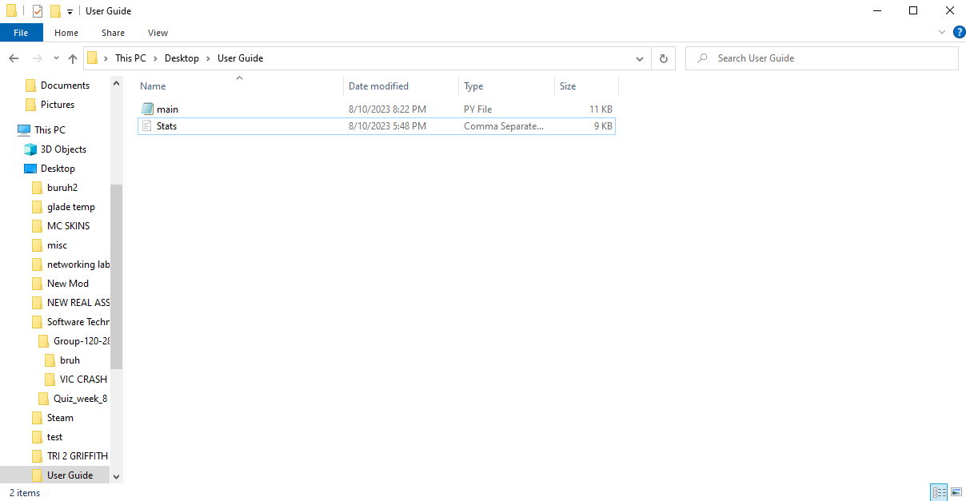

**STEP 2 :**

Run the program, and you should be greeted with the best user interface known to man.

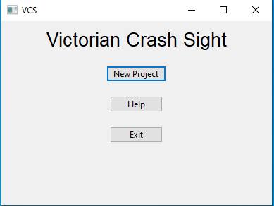

**STEP 3 :**

There are three options in the menu, these are: **1)** New Project this creates a new project to start manipulating the data from the stats file. **2)** Help direct you to this file. **3)** Exit closes the program.

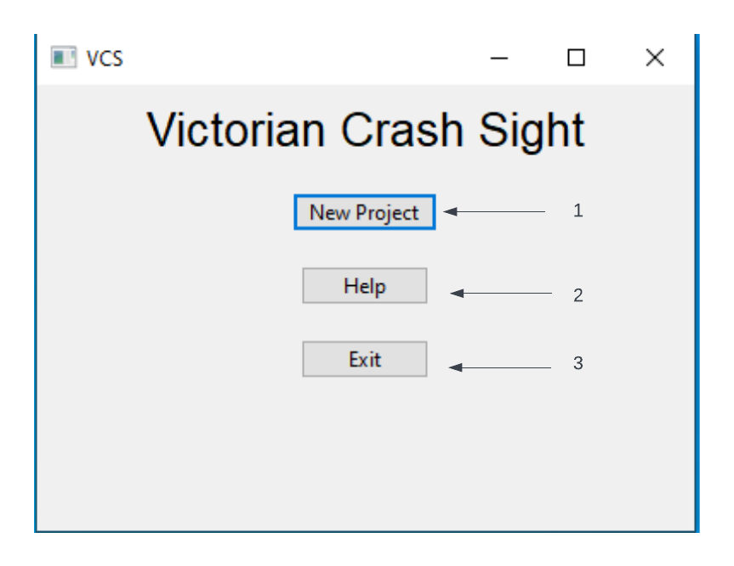

**Enter the filters**

**STEP 4:**

Open a new project, you will be greeted with multiple options to manipulate the data from stats, a start and end dates are entered by clicking on the day/month/year if an incorrect date is entered, finish the input then click the incorrect input and type again. Accident type is what filters the data. There are multiple options including but not limited to Struck Pedestrian, Collision with Car etc. Has Alcohol is a filter that allows you to remove or include alcohol involved accidents.

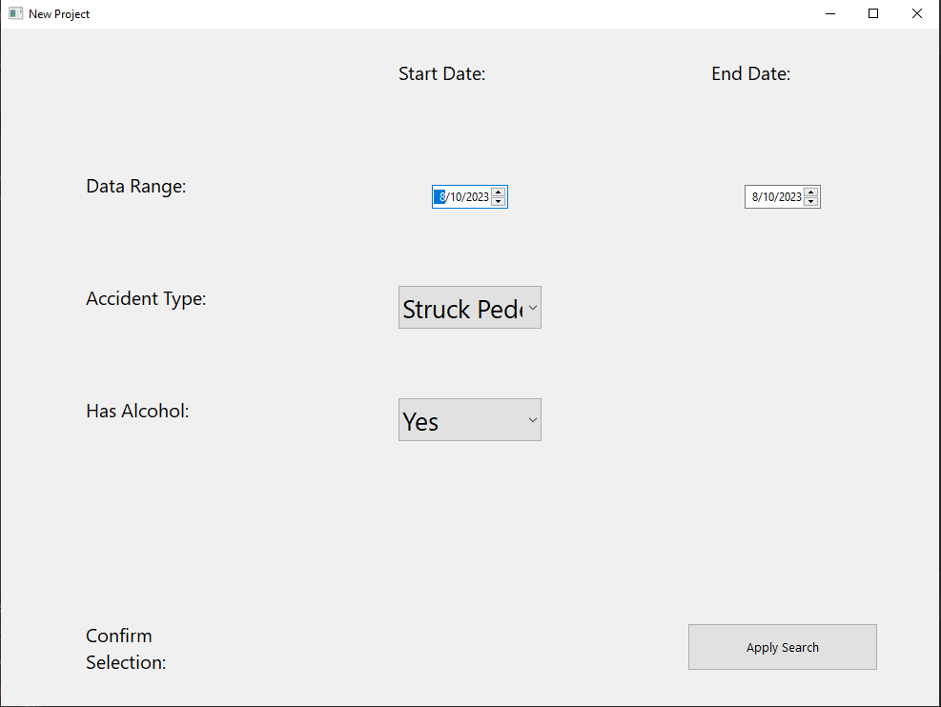

**Display Data**

**STEP 5:**

Once you are happy with the filters click the apply search button, this will then create a number of graphs to view your data. It will also create PNGS of the graphs made. 